**DAILY ONLINE ACTIVITIES SUMMARY**

|  |  |  |  |  |  |  |  |  |
| --- | --- | --- | --- | --- | --- | --- | --- | --- |
| **Date:** | **03-06-2020** | | | | | **Name:** | **Shetty Disha Ravindra** | |
| **Sem & Sec** | **VI B sec** | | | | | **USN:** | **4a17cs087** | |
| **Online Test Summary** | | | | | | | | |
| **Subject** | | PAP(assignment 1) | | | | | | |
| **Max. Marks** | | 20 | | **Score** | | | 18 | |
| **Certification Course Summary** | | | | | | | | |
| **Course** | Data Structures and Algorithms in Java | | | | | | | |
| **Certificate Provider** | | | **-** | | **Duration** | | | 1.5hrs |
| **Coding Challenges** | | | | | | | | |
| **Problem Statement:1]**  Write a python program to generate prime number in an interval  2] Given an array of positive integers. Write a C Program to find inversion count of array. | | | | | | | | |
| **Status:executed** | | | | | | | | |
| **Uploaded the report in Github** | | | | | **Yes** | | | |
| **If yes Repository name** | | | | | **Disha_Shetty** | | | |
| **Uploaded the report in slack** | | | | | **Yes** | | | |
| **PYTHON ASSIGNMENT PROGRAM**  **1]** **Python Program to Find the Largest Number in a List without using sorting algorithm**  Screenshot (91).png | | | | | | | | | |

Online Test Details: (Attach the snapshot and briefly write the report for the same)

Certification Course Details: (Attach the snapshot and briefly write the report for the same)

Coding Challenges Details: (Attach the snapshot and briefly write the report for the same)

Online test

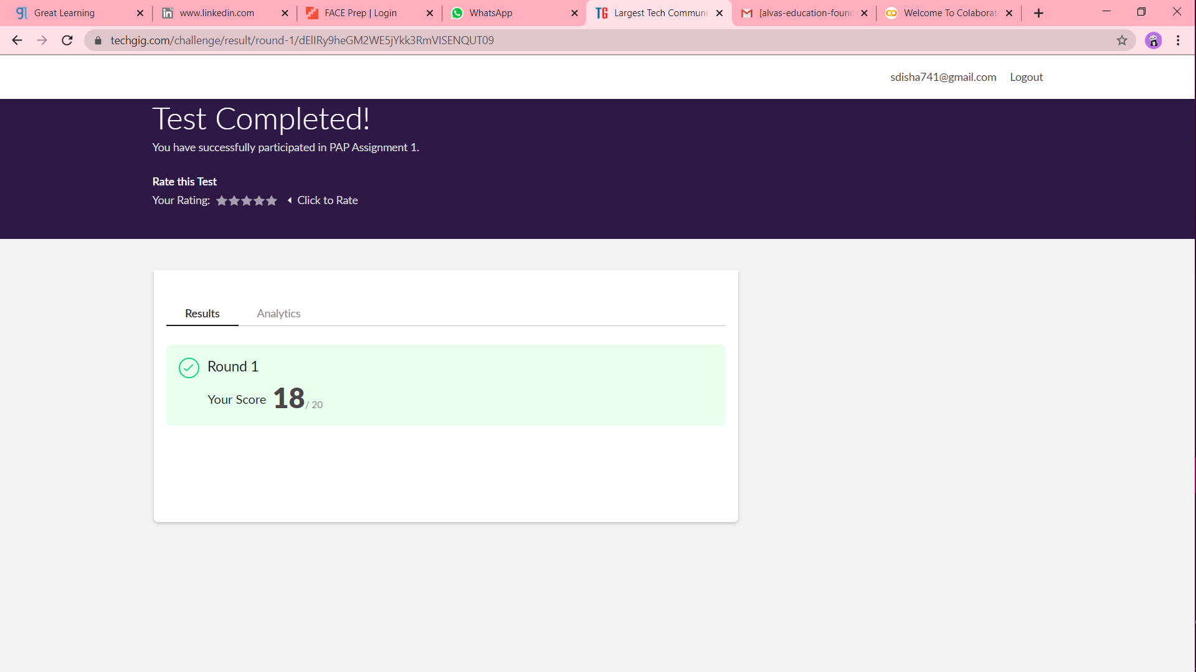

Certification progress



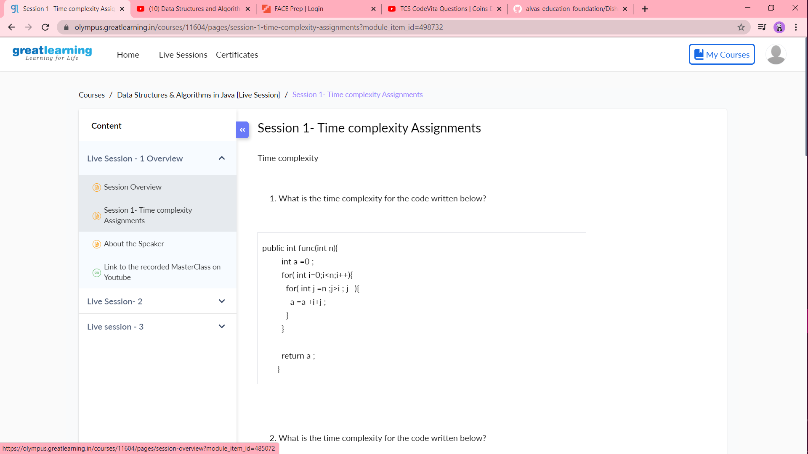

Coding challenge output

1]

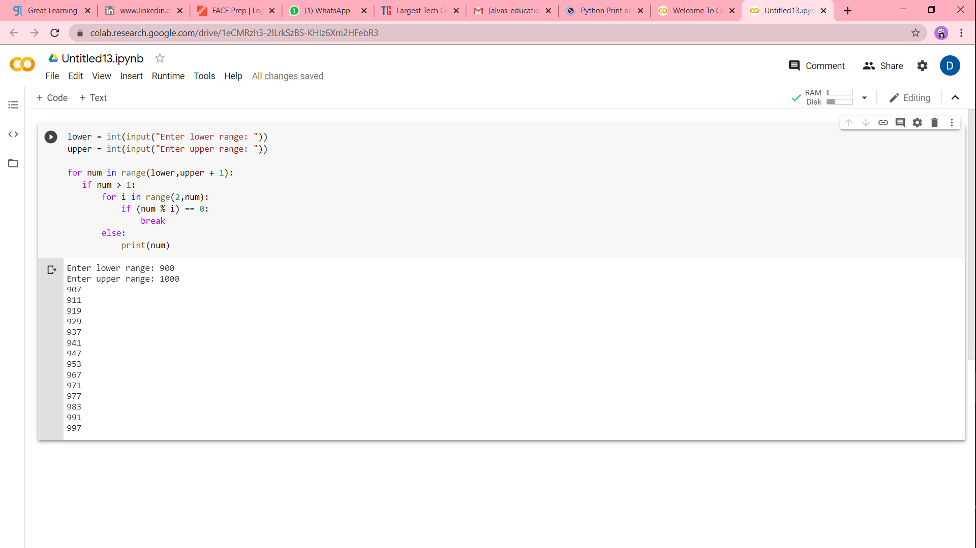

2]

